**SỬA BÀI THEO YÊU CẦU CỦA PHẢN BIỆN**

* Bản thảo đã được kiểm tra cẩn thận về định dạng, cấu trúc, câu từ tiếng Anh, và các chi tiết khác theo quy định của tạp chí.

* Việc sản xuất gạch sử dụng FA thay thế hoàn toàn xi măng có hiệu quả như thế nào so với xi măng? Xin tác giả trao đổi thêm về co ngót của gạch vì FA sẽ gây ra co ngót lớn hơn OPC dẫn đến viên gạch dễ bị nứt trong quá trình sử dụng.

***Tác giả phản hồi:***

1. Như được đề cập ở rất nhiều nghiên cứu trên thế giới rằng việc sản xuất và sử dụng xi măng có nhiều tác động tiêu đến môi trường như cạn kiệt nguồn tài nguyên thiên nhiên (đá vôi), thải ra môi trường một lượng lớn các khí thải gây hiệu ứng nhà kính (CO2 và các khí độc hại khác), v.v. Do đó, nghiên cứu này sử dụng tro bay để thay thế hoàn toàn xi măng nhằm hạn chế các tác động tiêu cực nêu trên. Mặt khác, tro bay cũng là một loại phế thải rắn từ các hoạt động công nghiệp, việc ứng dụng tro bay trong sản xuất gạch cung cấp một giải pháp tích cực và hiệu quả trong việc xử lí nguồn phế thải này. Hơn nữa, do là phế thải nên giá thành của tro bay thấp hơn rất nhiều so với xi măng, từ đó hiệu quả kinh tế cũng đạt được.

2. Xin được lưu ý rằng, việc sản xuất và thử nghiệm kết quả của loại gạch dùng trong nghiên cứu này được tiến hành dựa trên tiêu chuẩn Việt Nam TCVN 6477:2011 và TCVN 6355:2009, trong đó không đề xuất việc đo co ngót của gạch xây dựng. Chính vì thế, trong nghiên cứu này tác giả không đề cập tới nội dung này. Tác giả cũng xin chia sẻ thêm ý kiến cá nhân rằng việc sử dụng tro bay trong gạch (trong bê tông hay thậm chí vữa) đều mang lại hiệu quả trong việc hạn chế co ngót của vật liệu so với việc sử dụng xi măng. Được biết một cách phổ biếng rằng nhiệt phản ứng “cement hydration” là lớn hơn nhiều so với phản ứng của tro bay và một số vật liệu pozzolan khác (tro trấu, tro đáy,…). Do đó, sử dụng xi măng sẽ có nguy cơ xảy ra viết nứt cao hơn so với sử dụng tro bay. Tuy tác giả không đưa ra số liệu đo nhiệt phản ứng cụ thể cho riêng nghiên cứu này, nhưng nội dung này cũng đã được thảo luận và chứng minh bởi rất nhiều nghiên cứu trên thế giới (tác giả đơn cử một tài liệu tham khảo như đường dẫn bên dưới).

Link tham khảo: <http://ascelibrary.org/doi/abs/10.1061/(ASCE)0899-1561(2003)15%3A2(153)>

* Việc sử dụng tro trấu thô thay thế cát sẽ làm giảm chất lượng gạch như bài báo lại chỉ ra. Vậy cơ sở nào để tác giả đề xuất việc thay thế này? Nguồn tro trấu thô hiện nay có đủ nhiều để đưa vào sản xuất đại trà hay không?

***Tác giả phản hồi:***

1. Kết quả ở nghiên cứu này cho thấy sửng dụng nhiều tro trấu thô sẽ làm giảm cường độ, tăng độ rỗng và độ hút nước của viên gạch. Tuy nhiên tro trấu thô góp phần làm giảm trọng lương viên gạch, làm cho nó nhẹ hơn một cách đáng kể. Kết quả cường độ nén cho thấy gạch được sản xuất trong nghiên cứu này có cường độ cao hơn rất nhiều so với gạch xâu dựng thông thường (thông thường chỉ yêu cầu Mác 75 hoặc Mác 100 cho gạch xây). Trong nhiều trường hợp không cần cần độ quá cao mà quan tâm nhiều tới trọng lượng thì việc sử dụng gạch nhẹ hơn và có cường độ hợp lý sẽ được ưu tiên cân nhắc. Mặt khác, tro trấu thô hiện nay cũng là một loại phế thải, việc ứng dụng loại phế thải này trong sản xuất gạch cũng mang lại hiệu đáng kể trong giảm chi phí sản xuất, giảm thiểu ô nhiễm môi trường do loại phế thải này gây ra.

2. Nghiên cứu này chỉ ra một khả năng rất lớn trong việc ứng dụng các loại chất thải rắn (như tro bay, tro trấu) trong việc sản xuất vật liệu xây không nung. Đơn cử khu vực đồng bằng sông cửu long, một trong những vựa lúa lớn nhất cả nước, sản lượng vỏ trấu ước lượng hơn 3 triệu tấn /năm. Nếu tính trên cả nước thì con số này rỏ ràng không nhỏ. Từ đó cho thấy một khả năng rất lớn trong ứng dụng loại vật liệu này để sản xuất gạch với quy mô lớn.

Link tham khảo: <http://www.ecoenergy-vn.com/information/ung-dung-cua-vo-trau-13.html>

* Trong nghiên cứu chưa thấy đề xuất tỷ lệ thay thế tro trấu thô tối ưu?

***Tác giả phản hồi:***

Tỷ lệ thay thế tro trấu thô tối ưu đã được tác giả bổ sung vào phần kết luận của nghiên cứu này. Với 15% cát được thay thế bằng tro trấu thô thì tất cả các đặc tính kỹ thuật của viên gạch đều thỏa mãn yêu cầu của tiêu chuẩn Việt Nam hiện hành.

“Bricks with the optimum 15% of the natural sand replaced by URHA exhibited good properties, indicating that bricks of this type conform to the current Vietnamese standards for solid building bricks.”

ENGINEERING PERFORMANCE OF ALKALI-ACTIVATED GREEN BUILDING BRICKS INCORPORATING SOLID WASTE MATERIALS

ĐẶC TÍNH KỸ THUẬT CỦA GẠCH XÂY DỰNG THÂN THIỆN MÔI TRƯỜNG SẢN XUẤT TỪ CÁC CHẤT THẢI RẮN BẰNG PHƯƠNG PHÁP KIỀM KÍCH HOẠT

Trong-Phuoc Huynh1, Duy-Hai Vo2

1Department of Rural Technology; Can Tho University; htphuoc@ctu.edu.vn

2Department of Civil Engineering; Da Nang College of Technology; duyhai88@gmail.com

**Tóm tắt –** Nghiên cứu này nhằm đánh giá tiềm năng ứng dụng các nguồn chất thải rắn để sản xuất gạch xây dựng không nung thân thiện môi trường thông qua phương pháp kiềm kích hoạt. Trong đó, tro bay được kích hoạt bằng dung dịch xút nồng độ cao tạo thành chất kết dính cho sản xuất gạch. Tro trấu thô cũng được sử dụng để thay thế một phần cát. Những mẫu gạch được bảo quản ở nhiệt độ phòng cho đến ngày kiểm tra. Những mẫu gạch này trước tiên được kiểm tra về kích thước và các khuyết tật ngoại quan. Những ảnh hưởng của hàm lượng tro trấu thô trên các đặc tính kỹ thuật của gạch như cường độ nén, cường độ uốn, độ hút nước, khối lượng thể tích, khối lượng và thể tích rỗng cũng được nghiên cứu. Kết quả thực nghiệm cho thấy các mẫu gạch có các đặc tính tốt và đáp ứng yêu cầu của tiêu chuẩn Việt Nam. Những kết quả của nghiên cứu này chỉ ra tiềm năng lớn cho việc ứng dụng tro bay và tro trấu thô trong sản xuất gạch xây dựng thân thiện môi trường.

**Từ khóa –** Gạch xây dựng; tro bay; tro trấu thô; đặc tính kỹ thuật; chất thải rắn

**Abstract -** The present study evaluates the possibility of producing alkali-activated green building bricks through the application of geopolymerization technology incorporating various solid waste materials. Solid bricks were prepared in accordance with official Vietnamese product standards using fly ash (FA), an industrial byproduct, as the main binder material, which was activated by a strong sodium hydroxide (NaOH) solution. Unground rice husk ash (URHA) was used as a partial fine aggregate substitution (0%–45%) in order to provide a new use of this waste material. After casting, the brick samples were stored at room temperature until the ages required for testing. These samples were checked for dimensions and visible defects. The effects of URHA content on the engineering properties of the bricks, including compressive and flexural strengths, water absorption, bulk density, average weight, and void volume, were also investigated. Experimental results showed that the brick samples exhibited good engineering properties that well conform to the official Vietnamese standard. Compressive strength and flexural strength ranged, respectively, between 9.2–20.8 MPa and 3.2–5.3 MPa. These results demonstrate a great potential for using FA and URHA in the production of green building bricks.

**Keywords -** Green building brick; fly ash; unground rice husk ash; engineering performance; solid waste materials

# Introduction

Brick is one of the most common building materials used widely in construction industry. Globally, the annual brick production is approximate 1400 billion units [1]. In Viet Nam, the demand for building bricks, estimated by the government, in 2020 will be 42 billion units. Recently, there are many types of building bricks that are produced using various techniques, among which, conventional fired, such as clay bricks produced from natural clay with high- temperature kiln firing or cement bricks produced mainly from ordinary Portland cement (OPC), remain the most common of all brick types. Besides, there is a small quantity of building bricks that are produced from various sources of solid waste materials with or without kiln-fired.

However, the production of the conventional building bricks consumes a large quantity of energy and natural resources and causes negative effects to the environment since the production process generates a significant amount of carbon dioxide (CO2) and other harmful gases to the environment [2]. Thus, a suitable and effective way to reduce the contribution to greenhouse gas emission is increasing the use of supplementary cementitious materials fly ash (FA), rice husk ash (RHA), ground granulated blast-furnace slag (GGBFS), bottom ash (BA), etc. by partially or totally replacing the amount of OPC used and producing more environmentally sustainable construction materials. The Viet Nam Government is currently promoting the gradual replacement of conventionally fired clay bricks supplies with unfired building bricks (UBB) and encourages the use of UBB in all types of construction projects regardless of funding source, urban/ rural area, or number of stories.

Many previous works have studied the potential of using geopolymerization to produce bricks [1]. This technology uses the chemical reaction between amorphous silica-alumina rich solid materials that occurs in highly concen-trated alkaline solutions to form a very stable material called geopolymer, which has amorphous polymeric structures with interconnected Si–O–Al–O–Si. Moreover, using this technology to produce building bricks consumes less energy and releases significantly lower amount of greenhouse gases as compared to conventional brick-making techniques and FA is found to be a good source for producing bricks using geopolymerization [3]. Freidin [4] studied the effect of sodium silicate (Na2SiO3) content, forming pressure, and hydrophobic on the geopolymer bricks produced using a binder of FA and BA and an alkali-activator solution of Na2SiO3. As a result, this kind of brick met the official Israeli standards for conventional cement concrete blocks. Arioz et al. [5] studied the production of geopolymer bricks from FA, Na2SiO3, and sodium hydroxide (NaOH) solution. Their results showed that compressive strength of the samples ranged between 5 and 60 MPa and that the effect of curing conditions on brick density was insignificant.

Literature shows that the use of alkali-activated green building bricks greatly contributes to save natural resources, reduces pollution, and reduces waste disposal costs. Due to these advantages, the use of this brick type has become the trend of many countries in the world [1]. There is still not much information about the production of green brick using FA (activated by only NaOH) and unground rice husk ash (URHA). Therefore, the current study aims to evaluate the possibilities of producing alkali-activated green building brick incorporating these waste materials.

# Materials and experimental method

## Materials

This study used class-F fly ash (FA) as the main binder material of green building brick production. The physical and chemical characteristics of the ash are given in Table 1. Natural sand (modulus of fineness 3.0, density 2.65, and water absorption capacity 1.4%) and URHA (modulus of fineness 2.6, density 2.1, and water absorption capacity 27.6%) were used as fine aggregates in the brick mixtures. The scanning electron micrograph (SEM) of both the FA and URHA was presented in Figure 1. The NaOH solution with a concentration of 8 M was used as an alkali-activator. The local tap water was used as mixing water.

**Table 1:** Physical and chemical properties of FA

|  |  |  |
| --- | --- | --- |
| **Items** | | **FA** |
| Physical properties | Specific gravity | 2.08 |
| Mean particle size (μm) | 21.8 |
| Chemical composition (%) | SiO2 | 63.9 |
| Al2O3 | 20.0 |
| Fe2O3 | 6.64 |
| CaO | 3.84 |
| MgO | 1.25 |
| K2O | 1.08 |
| Others | 1.68 |

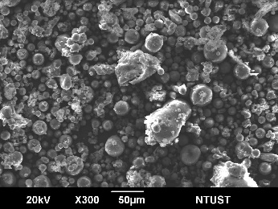 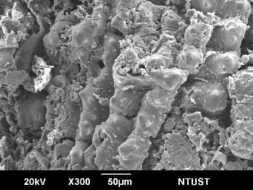

**Figure 1:** SEM images of FA (left) and URHA (right) particles

## Experimental method

The solid, green construction bricks of 220×105×60 mm in size were prepared in the steel mold with a constant water-to-binder ratios (w/b) of 0.46 and an applied forming pressure of 20 MPa. Various proportions of URHA (0%–45%) were used as a partial fine aggregate substitution in brick mixtures. Table 2 shows the mixture proportions of bricks in weight of each material. The brick samples were checked for dimensions, visible defects, compressive and flexural strengths, water absorption, bulk density, average weight, and void volume. The development in the strength of brick samples was measured at 3, 7, 14, and 28 days, while other brick properties were measured at 28 days. After casting, the bricks were cured at room temperature until the day required for testing. The preparation and test of brick samples were based on the official Vietnamese standards, TCVN 6477:2011 [6] and TCVN 6355:2009 [7].

**Table 2:** Mixture proportion for preparing brick samples

|  |  |  |  |  |  |
| --- | --- | --- | --- | --- | --- |
| **Mixture** | **Brick ingredient proportions (kg/m3)** | | | | |
| FA | Sand | URHA | NaOH | Water |
| FU00 | 495.6 | 1504.1 | 0.0 | 183.8 | 44.0 |
| FU15 | 485.6 | 1252.6 | 221.0 | 180.1 | 43.1 |
| FU30 | 475.9 | 1010.0 | 433.3 | 176.5 | 42.2 |
| FU45 | 466.7 | 779.0 | 637.3 | 173.1 | 41.1 |

# Results and discussion

## Dimensions and visible defects

These tests are performed to determine the dimension consistencies of the bricks. The test results are shown in Table 3. As the results, the dimensions of the brick samples well conformed to the Vietnamese standard [6], with a consistent shape and dimensions and no visible defects.

**Table 3:** Dimensions of the brick samples

|  |  |  |  |
| --- | --- | --- | --- |
| **Mixture** | **Dimensions (mm)** | | |
| Length | Width | Height |
| FU00 | 222.71 | 106.24 | 60.24 |
| FU15 | 222.24 | 106.51 | 61.31 |
| FU30 | 222.00 | 106.34 | 61.92 |
| FU45 | 222.43 | 106.52 | 61.91 |
| Limits [6] | 220 ± 6 | 105 ± 4 | 60 ± 3 |

## Compressive strength

Compressive strength is an important property used to evaluate brick quality. Figure 2 shows the compressive strength development of brick samples under different URHA replacement levels. It could be observed that the compressive strength of all of the brick samples increased with curing age. This may due to the positive relationship between curing age and the reaction of the pozzolanic materials and the alkali-activator solution, generating more gel to fill more voids within the bricks and creating an increasingly dense structure [8].

Moreover, Figure 2 demonstrated that using URHA as a natural fine aggregate replacement in the brick mixture significantly reduced compressive strength. The 28-day-old brick samples with 0%, 15%, 30%, and 45% URHA replacement levels had the respective compressive strength of 20.8 MPa, 13.8 MPa, 10.8 MPa, and 9.2 MPa. Thus, the respective compressive strengths were averagely 33.7%, 48.2%, and 55.9% below that of the no URHA bricks. These results showed that the more the URHA content, the lower the compressive strength values. This inverse relationship is attributable to the increasing pores volume that is associated with increasing the URHA replacement level since URHA is made up of highly porous particles (Figure 1). The loss of structural compactness led to lower compressive strength in the bricks with higher levels of URHA content.



**Figure 2:** Compressive strength development of brick samples under various URHA replacement levels

However, the results clearly show that the brick samples exhibited high compressive strength that conforms well to the standard requirements as a good quality solid building bricks [6].

## Flexural strength

Flexural strength is another important parameter used to assess the engineering quality of bricks. The development in flexural strength of brick samples under different URHA replacement levels is presented in Figure 3. Similar to the compressive strength, the flexural strength of brick samples increased with time at all levels of URHA replacement.



**Figure 3:** Flexural strength development of brick samples under various URHA replacement levels

This study found that the replacement of natural fine aggregate by URHA reduced the flexural strength of brick samples significantly (Figure 3). After 28 days, the flexural strengths of the samples with 0%, 15%, 30%, and 45% URHA were 5.3 MPa, 4.6 MPa, 4.1 MPa, and 3.2 MPa, respectively, which were approximately 12.5%, 22.0%, and 39.9%, respectively, above the value of the free-URHA bricks. These lower values were caused primarily by the presence of highly porous URHA particles (Figure 1), which reduced structural density and flexural strength. These results further confirm the relationship between higher URHA content and reduced strength. Although the URHA-brick samples showed a reduced flexural strength, the strength values were high and well-conformed to the standard requirements as a good quality solid building bricks [6].

## Water absorption

Water absorption is an important parameter affecting the durability of a building brick. It is noted that the less infiltration of water in the bricks, the more durable of the bricks. Figure 4 shows the results of water absorption test on 28-day-old brick samples.

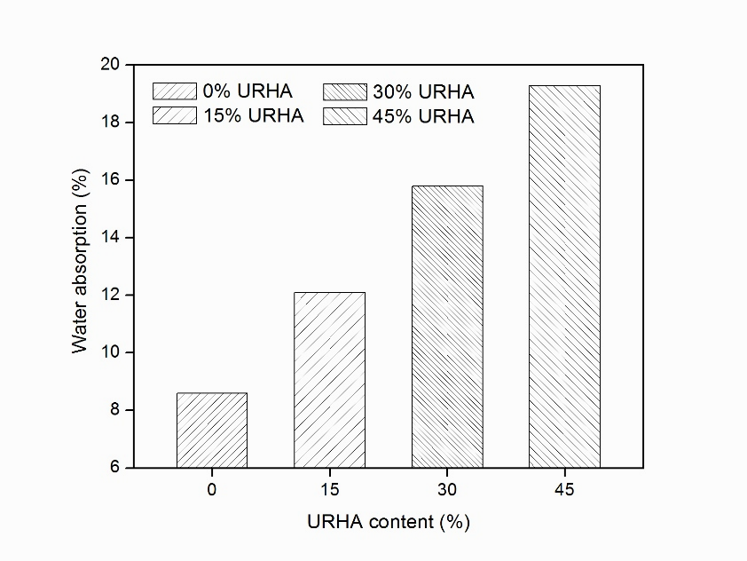

**Figure 4:** The relationship between water absorption and URHA content in 28-day-old brick samples

The water absorption test result shows a proportional relationship between water absorption capacity and URHA content in the bricks. Figure 4 shows clearly that replacing natural fine aggregate with URHA significantly increased the water absorption of brick samples. The higher water absorption rates were observed from the samples with higher URHA content. This is mainly attributable to the aforementioned significantly more porous nature of URHA particles (Figure 1) than of natural fine aggregate. The water absorption levels of the brick samples with 0%, 15%, 30%, and 45% URHA content in the mixture were 8.6%, 12.1%, 15.8%, and 19.3% corresponded with respective 28.9%, 45.6%, and 55.4% increases in water absorption in URHA-bricks as compared with no URHA bricks. These results are consistent with the development in the brick strength. Moreover, the water absorption capacity of brick samples containing over 15% URHA exceeded the permitted limit of 14% [6].

## Bulk density

The bulk density value is the key indicator used to classify solid building bricks. The experimental result of average bulk density for 28-day-old brick samples is shown in Figure 5. As observed from Figure 5, all of the URHA-bricks had bulk density values that were significantly lower than the bricks without URHA.

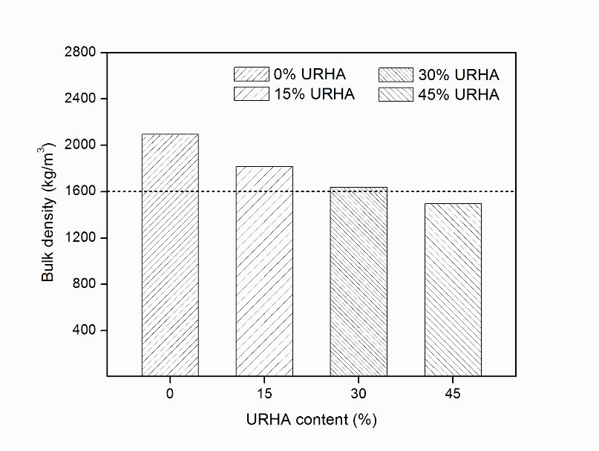

**Figure 5:** The relationship between bulk density and URHA content in 28-day-old brick samples

This study found that adding URHA to the mixture reduced the bulk density of bricks significantly. This was mainly due to the much lower specific density of URHA as compared to that of natural sand, which reduced mass per-unit-volume and caused the lower density value. For bricks with 15%, 30%, and 45% of URHA content, there were respective 13.3%, 21.9%, and 28.6% decreases in the bulk densities in comparison to the no URHA bricks. However, the bulk density values of brick samples with 45% URHA replacement level were below 1600 kg/m3, which is the minimum standard requirement for a solid building brick [6].

## Average weight

Figure 6 shows the average weight of 28-day-old brick samples under various URHA replacement levels.

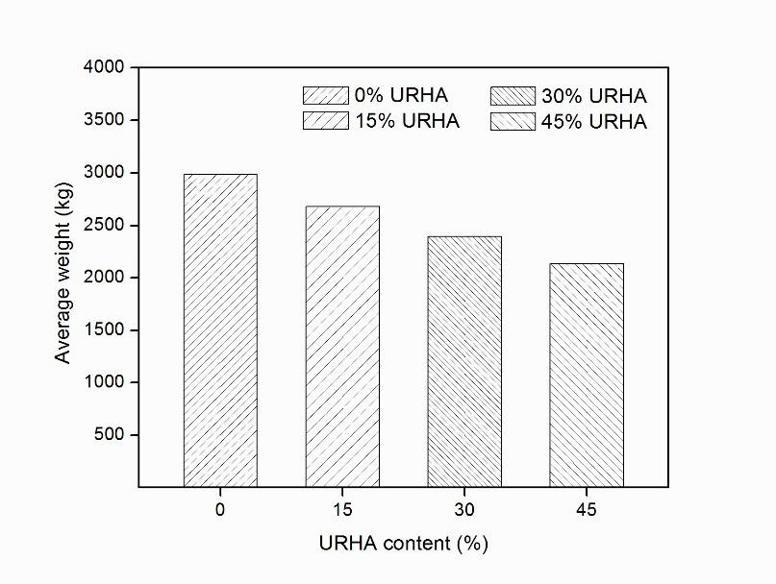

**Figure 6:** The relationship between average brick weight and URHA content in 28-day-old brick samples

Figure 6 indicates that lower bulk density values were associated with lighter brick weight and that the average weight of brick samples fell remarkably at higher levels of URHA replacement. This trend meets expectations due to the increasing number of voids formed within the bricks by the highly porous URHA particles (Figure 1). For bricks with 15%, 30%, and 45% of URHA content, there were 10.3%, 19.9%, and 28.5% decreases in the average brick weight, respectively, in comparison to the URHA-free bricks.

## Void volume

Void volume is an important indicator used to evaluate the quality of building bricks. This value relates closely to strength and absorption capacity of bricks, with less void volume associated with less water absorption and higher brick strength. The result of the void volume test for the 28-day-old brick samples is shown in Figure 7.

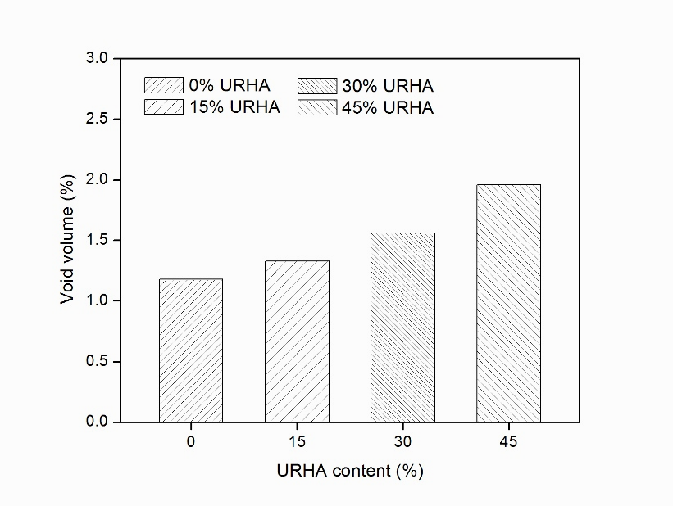

**Figure 7:** The relationship between void volume and URHA content in 28-day-old brick samples

The test result shows that adding URHA increased the void volume within the bricks significantly and that the URHA-brick samples had much higher void volume than the no URHA bricks. This may be attributable to the high porosity caused by the highly porous particles in URHA (Figure 1). However, all of the brick samples returned void volumes that were significantly below the maximum 65% allowed under the official standard for construction bricks [6]. This result is consistent with the water absorption test result as well as with the strength development of brick samples.

# Conclusions

The following conclusions may be drawn from the results of the experiments:

- All of the brick samples used for the present study were of a nice shape, consistent dimensions, and free of visible defects.

- The replacement of natural fine aggregate by URHA significantly affected all engineering properties of the bricks. The compressive and flexural strengths, bulk density, and average weight of brick samples decreased, whereas the void volume and water absorption capacity increased, as increasing the URHA replacement level.

- Bricks with the optimum 15% of the natural sand replaced by URHA exhibited good properties, indicating that bricks of this type conform to the current Vietnamese standards for solid building bricks.

- The results of the present study support the use of FA and URHA in the production of alkali-activated green building bricks.

# References

Zhang L. Production of bricks from waste materials – A review. Construction and Building Materials, 2013; 47: 643–655.

Reddy B.V.V, Jagadish K.S. Embodied energy of common and alternative building materials and technologies. Energy and Buildings, 2003; 35: 129–137.

Hwang C.L, Huynh T.P. Effect of alkali-activator and rice husk ash content on strength development of fly ash and residual rice husk ash-based geopolymers. Construction and Building Materials, 2015; 101: 1–9.

Freidin C. Cementless pressed blocks from waste products of coal-firing power station. Construction and Building Materials, 2007; 21: 12–18.

Arioz O, Kilinc K, Tuncan M, Tuncan A, Kavas T. Physical, mechanical and microstructure properties of F type fly ash based geopolymer bricks produced by pressure forming process. Advances in Science and Technology, 2010; 21: 69–74.

Vietnamese standard TCVN 6477:2011. Concrete bricks. Vietnam: Ministry of Construction; 2011.

Vietnamese standard TCVN 6355:2009. Bricks – Test methods. Vietnam: Ministry of Construction; 2009.

Hwang C.L, Huynh T.P. Investigation into the use of unground rice husk ash to produce eco-friendly construction bricks. Construction and Building Materials, 2015; 93: 335–345.

*(BBT received: …/…/2016, Accepted: …/…/2016)*

**About author(s)**

|  |  |
| --- | --- |
| C:\Users\Huynh\Dropbox\Smart Cards\Phuoc (nen trang).JPG | Trong-Phuoc Huynh  - Master and Ph.D. in Construction Materials at National Taiwan University of Science and Technology.  - Job (position and address): Lecturer, Can Tho University.  - Major field: Concrete science and technology; green and high-performance concrete; light-weight concrete; alkali-activated materials and geopolymers.  - Phone: (+84) 979416113 |
| Description: E:\DUYHAI\DUY HAI\IMAGE\hinh the\Hinh the.jpg | Duy-Hai Vo  - Master in Civil Engineering at The University of Da Nang; Ph.D. student in Construction Materials at National Taiwan University of Science and Technology.  - Job (position and address): Lecturer, Da Nang College of Technology.  - Major field: High-performance concrete; light-weight concrete; green concrete.  - Phone: (+84) 972277549 |