Correlation-Delay-Shift-Keying System for Low-rate Wireless Communications

HỆ THỐNG KHÓA DỊCH TRỄ TƯƠNG QUAN CHO TRUYỀN THÔNG Vô TUYẾN TỐC ĐỘ THẤP

Nguyen Xuan Quyen

School of Electronics and Telecommunications, Hanoi University of Science and Technology, Vietnam

**Abstract -** In this paper, we study the performance of a correlation-delay-shift-keying (CDSK) system for low data-rate applications in wireless communications. The low-rate data modulates the chaotic spreading sequence by means of a CDSK modulator at baseband. By using a RF modulator, the baseband CDSK-modulated signal is up-converted into a RF passband signal which is then transmitted on the antenna. These modulators allow the transmitter to be able to adjust flexibly the chip period compared with bit duration and locate the transmitted signal at a desired or allocated RF band. The receiver performs in turn the corresponding RF and CDSK demodulations to recover the data. A wireless channel affected by noise, fading, multipath, and delay-spread in the context of low-rate and short-range transmission of the chaotic spread-spectrum signals is described. Schemes for the transmitter and receiver under the impact of the wireless channel are then developed. Simulated results are shown to evaluate the effect of the spreading factor, modulation delay, and the number of transmission paths on the system performance. Our findings show that the low-rate CDSK system can exploit the multipath nature of wireless channels for improving the BER performance.

**Key words –** Chaos; Chaos-based Communications; Correlation-delay-shift-keying; CDSK; Low-rate transmission; Wireless communications.

**Tóm tắt –** Bài báo nghiên cứu hiệu năng của một hệ thống khóa-dịch-trễ-tương quan (CDSK) cho các ứng dụng tốc độ thấp trong truyền thông vô tuyến. Dữ liệu vào được điều chế bởi chuỗi hỗn loạn sử dụng bộ điều chế CDSK ở băng cơ sở. Tín hiệu điều chế băng cơ sở sau đó được đổi tần lên một băng tần RF và phát lên ăng-ten. Các bộ điều chế này cho phép máy phát có thể điều chỉnh linh hoạt tốc độ chip so với tốc độ bit, đồng thời đặt phổ của tín hiệu phát ở băng tần mong muốn. Máy thu thực hiện lần lượt giải điều chế RF và CDSK để khôi phục lại dữ liệu. Một kênh truyền vô tuyến dưới tác động của nhiễu, fading và trải trễ đa đường trong ngữ cảnh truyền dẫn tốc độ thấp và cự ly ngắn được mô tả. Các sơ đồ cho máy phát và máy thu được đề xuất. Các kết quả mô phỏng số chỉ ra rằng hệ thống CDSK tốc độ thấp có thể tận dụng đặc tính đa đường của kênh truyền vô tuyến để cải thiện hiệu năng BER.

**Từ khóa –** Hỗn loạn; Truyền thông hỗn loạn; Khóa dịch trễ tương quan; CDSK; truyền dẫn tốc độ thấp; truyền thông vô tuyến.

# Introduction

Chaotic signals with random noise-like behavior and broadband spectrum have been proposed as a secure alternative of pseudo-noise sequences in spread-spectrum communications [1]. Owing to robust performance in multipath fading channels, non-coherent chaos-based systems were proposed for wireless communications [2]. The most widely studied system is differential chaos shift keying (DCSK), where a reference chaotic sequence is sent, followed by the same sequence modulated by the binary data [3]. The application of the existing wireless techniques such as FM, MIMO, OFDM, UWB to the DCSK system has been recently investigated [4][6]. Beside the DCSK-based systems, another non-coherent system, i.e., Correlation-delay-shift-keying (CDSK), has been also studied significantly [7]. In CDSK, the reference sequence and the data-bearing sequence after a certain time delay are added together. As a result, the reference and data-bearing sequences are simultaneously transmitted in each bit duration. Since no individual reference signal is sent, the bandwidth efficiency of CDSK is improved in comparison with that of DCSK. In addition, by replacing the switch in DCSK by the adder, CDSK allows a continuous operation of the transmitter, in other words, the transmitted signal is never repeated. This feature helps to improve the confidentiality of the CDSK system. However, because the sum of two chaotic sequences is sent in the same time, more interference is created after the correlation process at the receiving side. Owing to this reason, CDSK performs worse than DCSK. In order to improve the performance of CDSK, there have been several extended CDSK-based systems proposed such as Generalized CDSK (GCDSK), Frequency-modulated CDSK, Correlation multi-delay-shift-keying, Single-input multiple-output CDSK [8]-[11]. However, the price that the extended systems have to pay is the complexity of implementation. Furthermore, the channels used in the investigation of these systems are quite simple, just noisy or fading channels. The performance over a wireless channel affected by noise, fading, multipath with delay spread has not studied so far.

In this paper, we study the BER performance of a low-rate CDSK system over wireless channels. It is well-known that the short-range wireless applications with low data-rate become increasingly more popular in our daily lives today, e.g., automation and control at home, factory, warehouse; monitoring in safety, health, environment; situational awareness and precision asset location in military actions, firefighter operations, autonomous manifesting, and real-time tracking of inventory; and entertainment with learning games, interactive toys [12]. In the transmitter, the low-rate binary data is spectrum-spread by a discrete chaotic signal through CDSK modulation at baseband frequency. The baseband signal is then up-converted into a radio frequency (RF) passband by means of a conventional RF modulation technique. The implementation of the CDSK modulation at baseband and the RF band conversion before transmitting allows the transmitter not only to adjust flexibly the chip period compared with bit duration but also to locate the transmitted signal at the desired or allocated RF range. In the receiver, the RF signal after passing a wireless channel is demodulated to down-convert into the baseband again. The CDSK demodulation is then used to recover the original data. Interestingly, the numerically-simulated performance points out that with the simple architecture, the CDSK system can still exploit the low-rate characteristic of wireless channels in order to improve the system performance.

The rest of this paper is structured as follows: Section II describes the model of a wireless channel in the context of low-rate spread-spectrum signals. Description of the proposed CDSK system is presented in Section III. Simulation results are shown in comparison with the analyzed ones in Section IV. Finally, our conclusion is given in Section V.

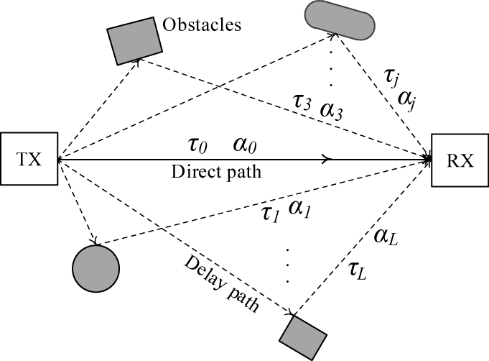

(a)

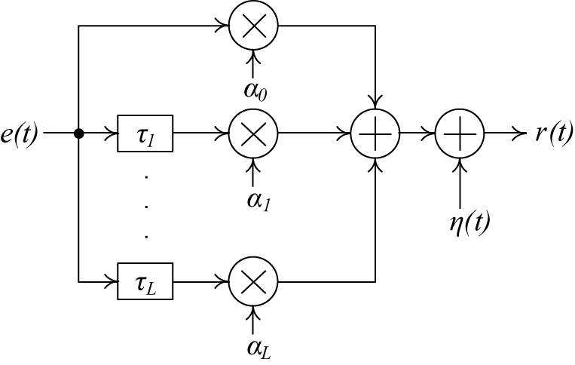

(b)

1. Wireless channel with low data-rate transmission of chaotic spreading signals: (a) Hypothetical propagation scenario, and (b) Channel model with one direct path and L−1 delay paths.

# Wireless Channel with Low-rate Spread-Spectrum

A simplified mathematical model for wireless channels in the context of low data-rate and short-range transmission of chaotic spreading signals is described in this section. In chaos-based communication systems, the spread-spectrum process is carried out by multiplying the chaotic spreading sequence with the binary data. To expand the spectrum, the chip duration of the chaotic sequence is generated to be much shorter than the bit duration  of the binary data. The ratio, , is the spreading factor which is the number of chips per bit. Suppose that the transmitted signal from the antenna of the transmitter comes to the antenna of the receiver after passing over a closed space with full of obstacles, e.g., tables, chairs, walls, and moving objects like people. Fig. 1(a) and Fig. 1(b) present a hypothetical scenario of the propagation in wireless channels and its model with one direct path and  delay paths, respectively. The signals after being reflected, refracted or diffracted, by the obstacles can reach the receiver with various delays, attenuation and from various paths. The path having a shortest transmission period is considered as the direct path and all others are the delay paths. With the assumption that the transmitter and receiver are stationary, the phase variations of the received signals in direct and delay paths can be ignored. The impulse response of the channel can be given by

*,* (1)

where and are corresponding to the time delay and fading coefficient of the path, and is the Dirac impulse [13]. The direct path has  and, while the delay paths have and  for. Here, the wireless channel is considered to have a slow fading characteristic. This means the fading coefficients change after each bit period and vary randomly according to the Rayleigh distribution given by

*,* (2)

with being the scale parameter of the distribution. It is notice that the mean and mean squared values of each fading coefficient are respectively determined by  and, where the condition, is  satisfied. In the context of low-rate transmission over short distance, the delays are assumed to be shorter than the chip duration of the chaotic sequence transmitted at baseband, satisfying the condition,  for. Under this condition, the output signal of the channel can be expressed by

 (3)

where ∗ is the convolution operator, and  are the transmitted and received signals, respectively,  is additive white Gaussian noise (AWGN) added by the channel. In the above parameters, the path delays , number of paths, and spreading factor *β* are constants, while the fading coefficient  and Gaussian noise, are independent random variables varying according to Rayleigh and Gaussian distributions, respectively.

# Low-rate CDSK System

Having the wireless channel model aforementioned in mind, the block diagram of the low-rate CDSK communication system is presented in Fig. 2.

## Transmitter

The chaotic reference sequence  at the output of the chaotic generator is produced by means of a chaotic map expressed by Chebysev polynomial function of order 2 [14],

, (4)

with the invariant probability density function (PDF) of, denoted by  being

 (5)

The values of,  , and are calculated as

 (6)

, (7)

, (8)

We employ this chaotic maps because of its good correlation characteristic which leads to good system performance [15]. In the CDSK modulator at baseband, the data stream with the bit duration  is spread in the frequency domain by multiplying with a spreading sequence which is the reference sequence after a fixed time delay. Note that the modulation delay  is chosen with any positive and nonzero value. It is not necessary to be equal to as in DCSK modulation. The output signal  of the CDSK modulator is the sum of the reference and data-bearing sequences. The value of discrete samples in the resulting signal can be expressed as

 , (9)

where is binary value of the  bit;, , and, are the values of the chip in the bit of the signals, , and, respectively. The CDSK modulated signal is then fed to a RF modulator. By means of the square-root-raised cosine filters with a roll-off factor, the spectrum of input signal is limited to a defined bandwidth satisfying Nyquist criterion, i.e.,. The filtered signal is modulated by a RF carrier. The goal of the RF modulation process is to up-convert the spectrum of the input signal from baseband into a RF band whose central frequency is the carrier frequency. The RF band signal  is finally transmitted on the wireless channel.

## Receiver

|  |
| --- |
| D:\RESEARCH\Conferences\Sigtelcom2016\Fig1.png |
| 1. Block diagram of the low-rate CDSK communication system |

The received signal is put into a corresponding RF demodulator, where the RF-band signal is down-converted into the baseband one which is then demodulated by means of a matched filter. The output signal  is sampled at a sampling cycle. It means that there are λ samples in each chip duration. Let’s consider the samples in the duration of the  chip in the  bit. Each sample is the sum of three components, i.e., the signal  and its delayed parts with duration of, the delayed parts with duration  of the  chip, and white Gaussian noise. Owing to the same chip duration, the samples in the duration of  have the same value. With no loss of generality, the chip duration  and all channel delays are assumed to be equal to a multiple of the sampling cycle τ. For the sake of mathematical representation, we denote. The value of samples falling into the duration of is determined by

 (10)

where  is the value of the  sample satisfying  in the  chip duration. The sampled signal after being delayed with the period of γ is correlated with itself by means of a multiplier and a sum calculator. The consecutive samples at the input are added together in each bit duration to

 (11)

where  and are the random functions given by

 (12)

 (13)

 (14)

 (15)

 (16)

with  and  being the random variables determined by

 (17)

 (18)

 (19)

 (20)

 (21)

The binary value of the bit is finally recovered base on the sign of the decision value.

# Simulation results

In this section, Monte Carlo simulations of the low-rate CDSK system for the above cases of the wireless channel are carried out. The different cases of the studied wireless channel are chosen as follows: one-path fading with, two-path fading with, , three-path fading with ,,,, , and four-path fading with ,,,, ,.

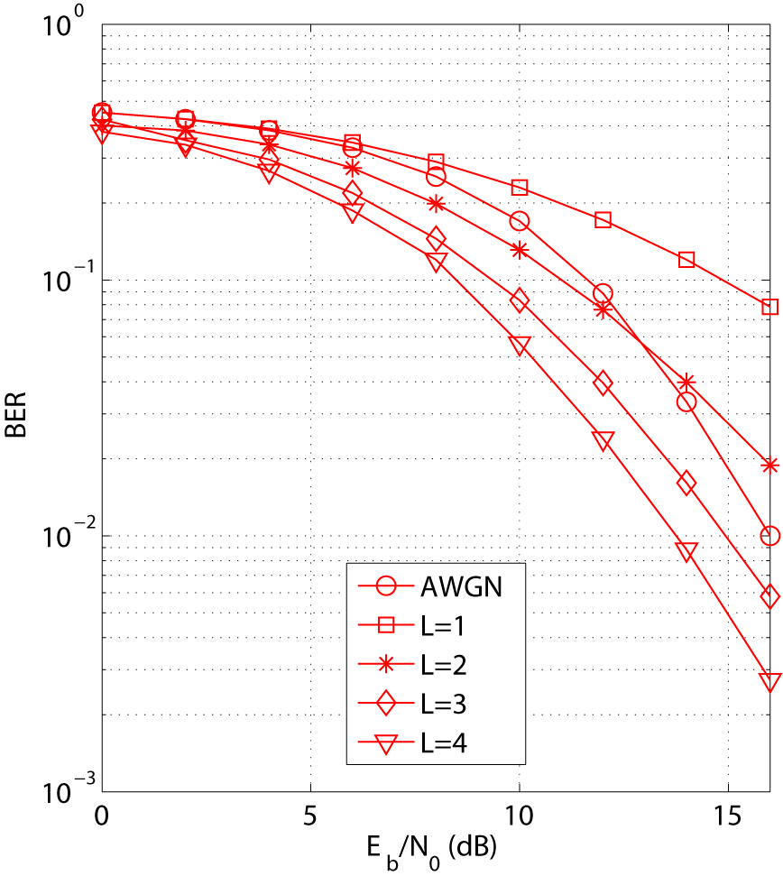

1. BER performance in different cases of the channel at β=64

The simulated performance with, in the different cases of the channel, i.e., AWGN, the number of path L increasing from 1 to 4, are shown in Fig. 4. It can be seen that the system in the case of AWGN performs better than in the cases of one-path fading and two-path fading for, while worse than in the case of three-path fading, four-path fading, and two-path fading for. In general, the system performance is significantly improved when the number of delay paths increases. For example, at the same value of, the BER values corresponding to  and  are, and. These results prove that the low-rate CDSK system can exploit the multipath characteristic to enhance the performance in wireless channels.

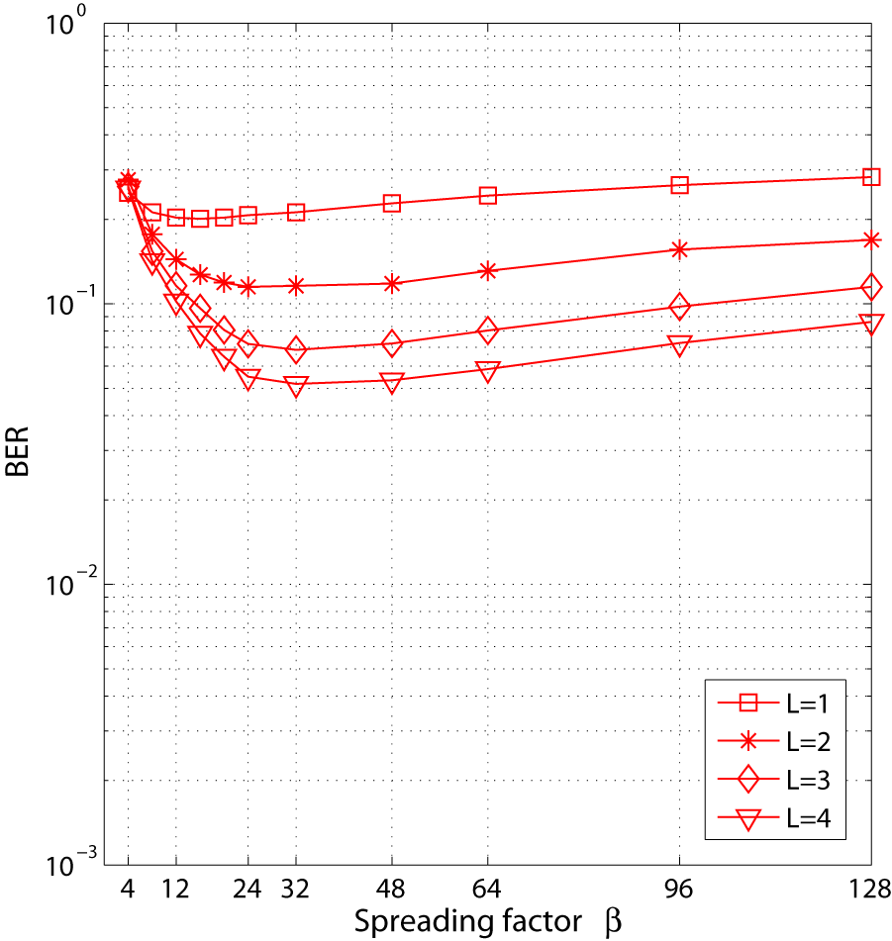

1. BER values against the spreading factor β at Eb/N0=10dB

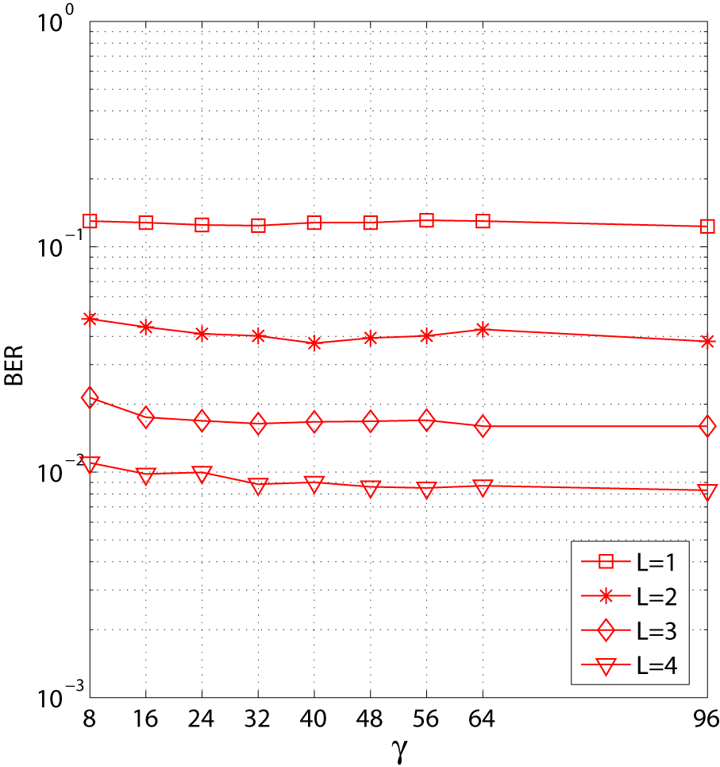

1. BER values against the modulation delay γ at β=64, Eb/N0=10dB

For a fixed value, the dependence of BER values upon the spreading factor is evaluated in Fig. 5. It clearly appears that with a specific number of paths, there is an optimal value of the spreading factor at which the system performance is the best. Specifically, the optimal spreading factor for the cases of are  respectively. For greater than the optimal value,increasing leads to the increment of the BER, while for  less than the optimal value, the BER increases when  reduces.

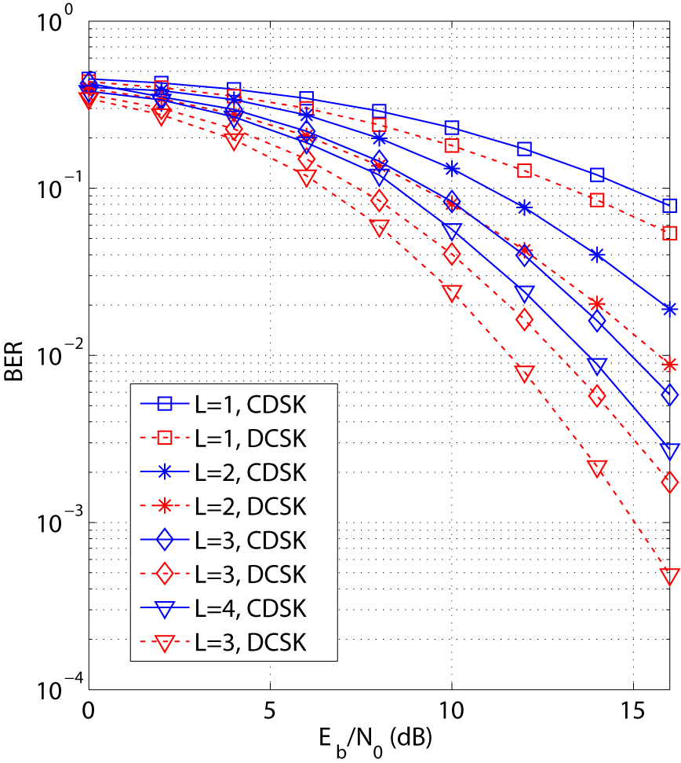

1. Performance comparison between CDSK and DCSK in the same conditions

To evaluate the effect of the modulation delay γ, we perform the numerical simulation for different values of. We can observe from Fig. 6 that the simulated BERs are almost constant and well matched to the analyzed ones for all the cases of. Beside the continuous variation without repeated signal, this feature can also help the CDSK system to improve the confidentiality. The transmitter and receiver can simultaneously change the value following a joint convention for each transmission instance.

The comparison of the simulated performance between two coherent systems, i.e., DCSK and CDSK, with the same spreading factor and in the same conditions of wireless channel is studied in Fig. 7. As aforementioned, owing to the sum of two chaotic sequences sent, more interference is created after the correlation process at the receiver. Therefore, the performance of CDSK is worse than that of DCSK. For example at the same, the BER values of CDSK and DCSK in the cases of are and ,respectively. This means that the CDSK system has to pay for the trade-off between the security and the performance compared with the DCSK one.

# Conclusion

BER performance of a CDSK system for low-rate wireless communications has been investigated in this paper. The model of wireless channel and the structure of the studied system in the context of transmitting the low-rate chaotic spreading signal are described. The performance against the number of paths, spreading factor, and modulation delay, is evaluated by the simulated results. We can see from the achievements that the low-rate CDSK system can perform well in wireless channels, particularly the system performance is significantly enhanced when the number of delay paths increases. In addition, the studied system can improve the confidentiality compared with the DCSK system, meanwhile still keep a simple structure of the transmitter and receiver.

References

[1] N. X. Quyen et al., “Chaotic direct-sequence spread-spectrum with variable symbol period: A technique for enhancing physical layer security,” *Computer Networks*, doi:10.1016/j.comnet.2016.06.022, 2016.

[2] G. Kaddoum, “Wireless chaos-based communication systems: a comprehensive survey,” *IEEE Access*, vol. 4, pp. 2621-2648, 2016.

[3] G. Kolumbon, B. Vizvari, W. Schwarz, and A. Abel, “Differential chaos shift keying: a robust code for chaos communication,” *in Proc. 4th Int. Workshop on Nonlinear Dynamics Electronic Syst.*, pp. 87-92, 1996.

[4] G. Kaddoum, “Design and performance analysis of a multiuser OFDM based differential chaos shift keying communication system,” *IEEE Trans. Commun.*, vol. 64, no. 1, pp. 249-260, 2016.

[5] N. X. Quyen, T. Q. Duong, A. Nallanathan, “Modelling, analysis and performance comparison of two direct sampling DCSK receivers under frequency non-selective fading channels,” *IET Communications*, vol. 10, no. 11, 2016, pp. 1263-1272.

[6] Y. Fang, J. Xu, L. Wang and G. Chen, “Performance of MIMO relay DCSK-CD systems over Nakagami fading channels*,” IEEE Trans. Circuits Syst. I-Reg. Papers*, vol. 60, no. 3, pp. 757-767, 2013.

[7] M. Sushchik, L. S. Tsimring, and A. R. Volkovskii, “Performance analysis of correlation-based communication schemes utilizing chaos,” *IEEE Trans. Circuits Syst. I, Fundam. Theory Appl.*, vol. 47, no. 12, pp. 1684-1691, 2000.

[8] W. N. Tam, F. C. M. Lau, and C. K. Tse, “Generalized correlation delay-shift-keying scheme for noncoherent chaos-based communication systems,” *IEEE Transactions on Circuits and Systems I*, vol. 53, no. 3, pp. 712721, 2006.

[9] Q. Ding and J.Wang, “Design of frequency-modulated correlation delay shift keying chaotic communication system,” *IET Commun*., vol. 5, no. 7, pp. 901-905, 2011.

[10] Marijan Herceg , Kruno Milicevic, Tomislav Matic, “Correlation-multidelay-shift-keying for chaos based communications,” *Wireless Personal Communications*, vol. 88, no. 2, pp. 283-294, 2016.

[11] J-Y. Duan, G-P. Jiang, and H. Yang, “Performance of a SIMOCDSK System over Rayleigh Fading Channels,” *Mathematical Problems in Engineering*, vol. 2013, Article ID 532653, 7 pages, 2013. doi:10.1155/2013/532653.

[12] J. Zheng, M. J. Lee, M. Anshel, “Toward secure low rate wireless personal area networks,” *IEEE Trans. Mob. Comput.*, vol. 5, no. 10, pp. 13611373, 2006.

[13] T. S. Rappaport, *Wireless Communications: Principles and Practice*. Prentice-Hall, 1996.

[14] T. Geisel and V. Fairen, “Statistical properties of chaos in Chebyshev maps,” *Phys. Lett. A*, vol. 105A, no. 6, pp. 263266, 1984.

[15] T. Kohda, A. Tsuneda, and A. J. Lawrance, “Correlational properties of Chebyshev chaotic sequences,” *J. Time Ser. Anal*., vol. 21, no. 2, pp. 181-191, 2000.

(BBT nhận bài: …/…/2016, phản biện xong: …/…/2016)

**Short Biography**

|  |  |
| --- | --- |
| D:\RESEARCH\JOURNALS\WirePerCom_journal-PBR\Photo_Quyen.png | - **Nguyen Xuan Quyen** received the Diploma of Engineer, Master and PhD degrees in Electronic Engineering and Telecommunications, from Hanoi University of Science and Technology, Vietnam in 2006, 2008 and 2013, respectively. From 2007-current, he has been serving as a senior lecturer at the School of Electronics and Telecommunications (SET), Hanoi University of Science and Technology (HUST), Vietnam. He has been a sandwich PhD student at the Institute for Smart System Technologies, Alpen-Adria Klagenfurt University, Austria during 2011-2012. From 2014-2015, he has worked as a postdoctoral researcher at the Department of Computer Architecture, Polytechnic University of Catalonia (UPC BarcelonaTech), Barcelona, Spain. He was also an academic visitor at the Department of Electronic and Computer Engineering, University of Limerick, Ireland in 2015 and School of Electronics, Electrical Engineering and Computer Science, Queen’s University Belfast, United Kingdom in 2016. His main research interests are microwave engineering, chaos-based digital communications and physical layer security, and wireless communications. Dr. Quyen has been a TPC member of the International Conference on Communications and Electronics (ICCE), the International Conference Advanced Technologies for Communications (ATC); the International Conference on Computing, Management and Telecommunications (ComManTel). He has also served as a reviewer for several journals such as [IEEE Transactions on Wireless Communications](http://ieeexplore.ieee.org/xpl/RecentIssue.jsp?punumber=7693), IET Communications, Wireless Personal Communications, [Circuits, Systems and Signal Processing](https://www.google.com/url?sa=t&rct=j&q=&esrc=s&source=web&cd=1&ved=0ahUKEwi1pujr95fNAhVElZQKHY3LB7MQFggcMAA&url=http%3A%2F%2Fwww.springer.com%2Fengineering%2Fcircuits%2B%2526%2Bsystems%2Fjournal%2F34&usg=AFQjCNHp4em2-jZfZ9M-UNNlioUweUEB1A&sig2=OGy1FmFAYbXaaiiELLb64Q&bvm=bv.124088155,d.dGo).  - Mobile: 0912.255.217 |

**Thông tin cụ thể:**

1. Họ và tên: Nguyễn Xuân Quyền

2. Học hàm, học vị: Tiến sĩ

3. Tên cơ quan: Trường Đại học Bách Khoa Hà Nội

4. Liên hệ: số mobile: 0912.225.217, quyen.nguyenxuan@hust.edu.vn