A STUDY ON DAMAGED STABILITY OF WOODEN FISHING BOATS
IN VIETNAM
Nguyen Thi Huyen Trang, Pham Truong Thi
The University of Danang - University of Science and Technology; nthtrang@dut.udn.vn, ptthi@dut.udn.vn

Abstract - In this paper, damaged stability of a Vietnamese wooden fishing boat is analyzed by a set of Theory in Register and by using the Autoship program. The purpose of this study is to optimize the distance between bulkheads to ensure the safety of the ship and also improve the economic efficiency. The authors use the Autoship program to simulate the 3D model of the ship and its positions in cases of the its water flooded one or more compartments. In this study, we mostly use the Added Weight Method to define the position, the change of draft, the change of trim, the heeling and the change of stability of the ship.
Key words - damaged stability; wooden fishing boat; Autoship; added weight method; watertight bulkhead.

Introduction
Studying of damaged stability of ships in Vietnam has not been properly concerned with. In addition, the building process of fishing boats is mostly based on experience though wooden fishing boats play a big role in the marine economy in our country because of their popularity and low cost. In recent years, there have been many serious seagoing accidents involved in wooden fishing boats that affect the lives and property of fishermen. This topic focuses on the study of damaged stability of wooden fishing boats and offers recommendations to increase the safety of ships, minimizing accidents caused by sinking at sea.

Approach and methods
A ship is said to be in a state of equilibrium when the resultant of all forces acting on it is zero and the resultant moment of the forces is also zero [1]. There are two methods that evaluate the equilibrium conditions of the ship:
Lost Buoyancy Method [2, 3]: This method assumes that the damaged compartment does not contribute to the total buoyancy of the ship. Hence, the ship loses a part of its water-plane, and its buoyancy, therefore reducing stability. This method is easier to use but the results obtained from this method are slightly less accurate than from the other methods.
Added weight method [2, 3]: The added weight method considers the flood water to be a weight added to a certain point in the ship. The problem is solved like a traditional weight addition case, and the trim and drafts are calculated over a set of iterations. Though this process is time-consuming, it provides more accurate results.
Based on this analysis, in this study, we mostly use the Added Weight Method to simulate the positions of flooding ship.
Input data of the wooden fishing boat in Da Nang is used in this study:
Table 1. Input data of the wooden fishing boat
No. | Parameters | Value | Unit
1 | L | 17.7 | (m)
2 | B | 6 | (m)
3 | d | 1.94 | (m)
4 | H | 2.75 | (m)
5 | α(C_{W}) | 0.92 | -
6 | β(C_{M}) | 0.92 | -
7 | δ(C_{B}) | 0.72 | -
8 | φ(C_{P}) | 0.78 | -
9 | L/B | 2.95 | -
10 | B/d | 3.09 | -
11 | B/H | 2.18 | -
12 | Δ | 152.66 | (T)
13 | ∇ | 148.94 | (m³)
14 | X_{C} | 0.063 | (m)
3D model simulation of the ship on Autoship program:
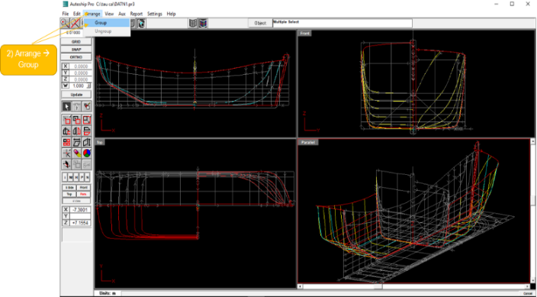
Figure 1. 3D model of the ship
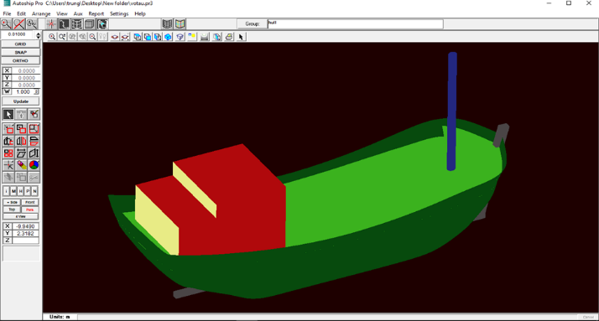
Figure 2. 3D model of the ship with superstructure
The calculation is done in some cases listed in Register [4].

Fully flooded one or more compartments
In this case, the problem can be solved like a solid weight added to a certain point on the ship.

Case 1: The fish hold No.1 is flooded

Determining the position of the ship by theory
The ship is at the condition when the consumables (provisions, potable water, and fuel) are at 100% full load.
- Displacement: D = 152.06 (T)
- $L_{tk}=17.7\left(m\right)$
- $B_{tk}=6.24\left(m\right)$
- Draft at this condition: d = 1.94(m)
- Moment to change Trim 1cm
$$M_{CT1cm}=0.984T/cm$$
From Hydrostatic curves:
- Center of water-lane: $X_{f}=-0.505\left(m\right)$
- Meta-center height: $\overset{_____}{GM}=2.993(m)$
- Long meta-center height: ${\overset{_____}{GM}}_{L}=60.753(m)$
Parameters of the fish hold:
- Volume of the compartment: $V_{1}=51\left(m^{3}\right)$
- Position of center of Gravity of the Compartment:
$$\left\{\begin{aligned}&X_{g}=0.364\left(m\right) \\ &Y_{g}=0\left(m\right) \\ &Z_{g}=1.35\left(m\right)\end{aligned}\right.$$
Based on theory:
- The weight of water considers the weight added to the ship:
$$p=γ∙V∙μ=1.025∙51∙0.6=31.365(T)$$
- Change of draft [5,6]:
$$ΔT=\frac{p}{ΔD_{j}}=\frac{31.365}{0.984}=31.875\left(cm\right)≈0.32\left(m\right)$$
- Change of meta-center height [5,6]:
$$Δ{\overset{_____}{GM}}_{t}=\frac{p}{D+p}∙\left(T+\frac{ΔT}{2}-\overset{_____}{GM}-Z_{g}\right)$$
$$=\frac{31.365}{152.06+31.365}∙\left(1.94+\frac{0.32}{2}-2.993-1.35\right)$$
$$=-0.38\left(m\right)$$
$${\overset{_____}{GM}}_{t}=\overset{_____}{GM}+Δ{\overset{_____}{GM}}_{t}=2.993-0.38=2.613\left(m\right)$$
- Change of longitudinal meta-center height [5, 6]:
$${\overset{_____}{GM}}_{L}≈\frac{D}{D+p}∙{GM}_{L}=\frac{152,06}{152.06+31.365}×60.753 =50.364\left(m\right)$$Angle of trim [5, 6]:
$$ψ=\frac{p∙\left(X_{g}-x_{f}\right)}{D∙{\overset{_____}{GM}}_{L}}=\frac{31.365∙\left(0.364+0.505\right)}{152.06∙50.364}=0.004$$
- Change of draft forward:
$$ΔT_{m}=ΔT+\left(\frac{L}{2}-x_{f}\right)∙ψ= \\ =0.32+\left(\frac{17.7}{2}+0.505\right)∙0.004=0.357\left(m\right)$$
- Change of draft aft:
$$ΔT_{l}=ΔT+\left(\frac{-L}{2}-x_{f}\right)∙ψ= \\ =0.32+\left(\frac{-17.7}{2}+0.505\right)∙0.004=0.287\left(m\right)$$

Using Autoship program to determine the position of the ship [7]
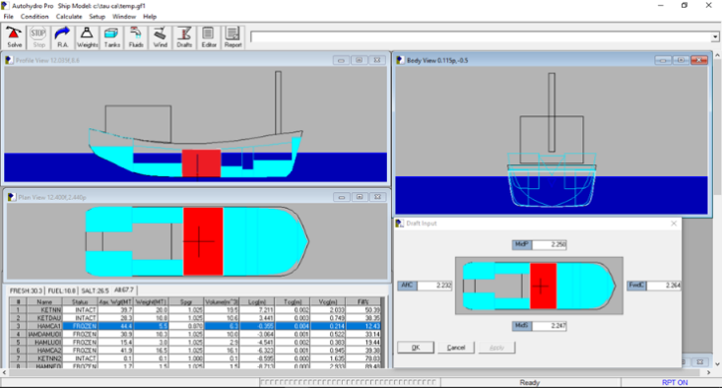
Figure 3. Position of ship with fish hold 1 flooded

Result comparison
Table 2. Comparison of the results of using Theory and AutoShip program
Change of draft | Based on theory | By AutoShip program | Deviation
Aft | $$ΔT_{l}=0.287(m)$$ | $$ΔT_{l}=0.295(m)$$ | 2.7%
Forward | $$ΔT_{m}=0.357(m)$$ | $$ΔT_{l}=0.321(m)$$ | 10%

Case 2: Fish hold No.2 is flooded

Determining the position of the ship by theory
The ship is at the condition when:
- Consumables (provisions, potable water, and fuel) are at 10% full load;
- Cargo is at 100% capacity.
Input data:
- D = 142.504 (T)
- d = 1.82(m)
- $M_{TC1cm}=0.979T/cm$
- $X_{f}=-0.543\left(m\right)$
- $\overset{_____}{GM}=3.025(m)$
- ${\overset{_____}{GM}}_{L}=63.339(m)$
Results:
${GM}_{l }$= 49.73 m
$$ΔT_{l}=0.076(m)$$
$$ΔT_{m}=0.766(m)$$

Using Autoship program to determine the position of the ship [7]
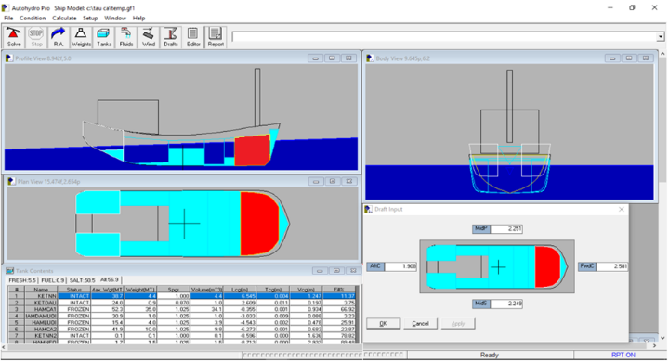
Figure 4. Position of the ship with the fish hold No.2 is flooded

Result comparison
Table 3. Comparison of the results of using Theory and AutoShip program
Change of draft | Based on theory | By AutoShip program | Deviation
Aft | $$ΔT_{l}=0.076(m)$$ | $$ΔT_{l}=0.075(m)$$ | 1.3%
Froward | $$ΔT_{m}=0.766(m)$$ | $$ΔT_{m}=0.723(m)$$ | 5.7%

Case 3: Freshwater tank is flooded
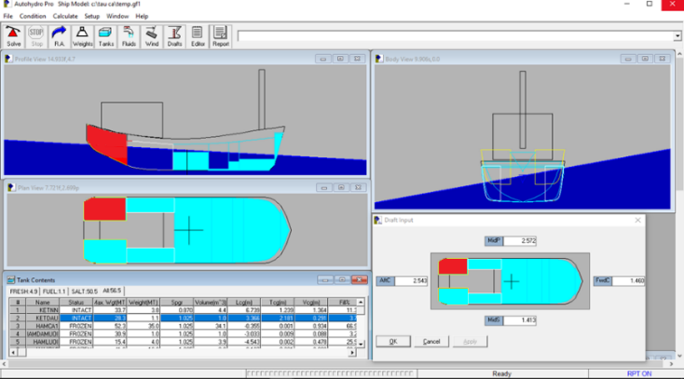
Figure 5. Position of ship with fresh water tank flooded

Case 4: Two fish holds are flooded
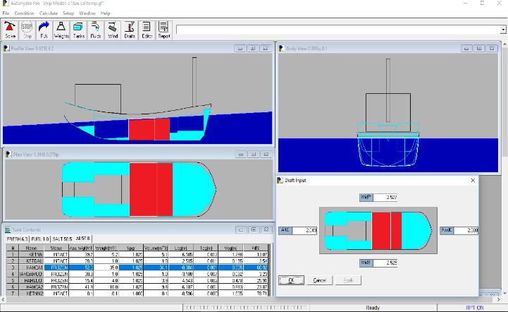
Figure 6. Position of the ship with two fish holds are flooded

Partially flooded one or more compartments
In this case, the phenomenon observed like adding a liquid weight to the ship, so the problem can be solved in the same way when a liquid weight is added to a certain point on the ship.
If the compartment is only partially full, free surface effect will exist.

Case 1: Fish hold No.1 is flooded
The ship is at the condition as follows:
- Consumables are at 10% full load.
- Cargo is at 20% capacity.
- 70% ice.
Hypothetically, the ratio of the floodable volume to the total volume of the compartment (permeability of the compartment) equals 70%.

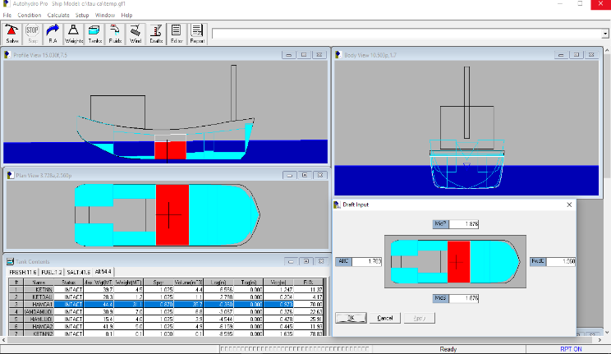
Figure 7. Position of the ship with the fish hold No.1 is
partially flooded

Case 2: Fish hold No.2 is flooded
The ship is at the condition as follows:
- Consumables are at 10% full load.
- Cargo is at 20% capacity.
- 70% ice.
Hypothetically, the ratio of the floodable volume to the total volume of the compartment (permeability of the compartment) equals 50%.
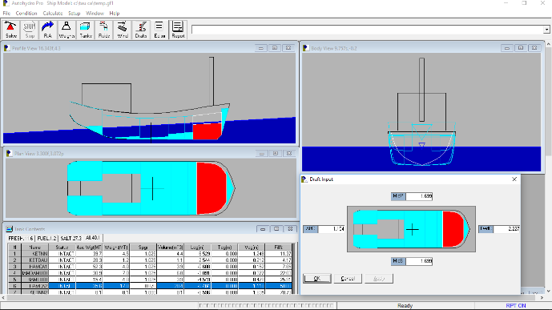
Figure 8. Position of the ship with the fish hold No.2 is
partially flooded

Case 3: Fish hold No.2 and the net hold are flooded
Hypothetically, the ratio of the floodable volume to the total volume of the compartment (permeability of the compartment) equals 50%.
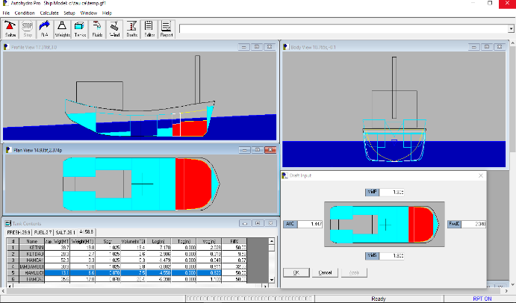
Figure 9. Position of the ship with the fish hold 2 and the net hold are partially flooded

Building the floodable length curve of the wooden fishing boat [5, 6]
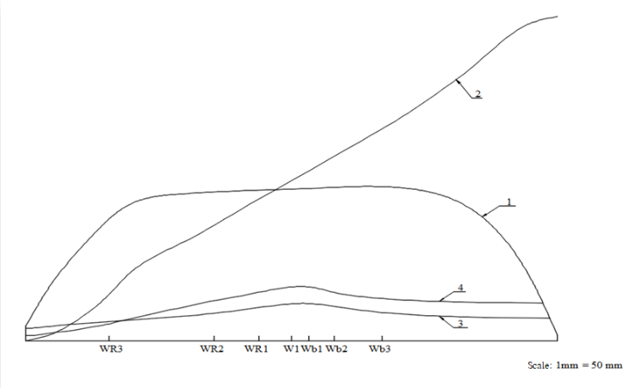
Figure 10. How to build the floodable length curve of a ship
- Curve 1: Transvers plane to the margin line;
- Curve 2: Intergrals of the curve 1;
- Curve 3: Maximum volume of each compartment;
- Curve 4: Floodable length curve.
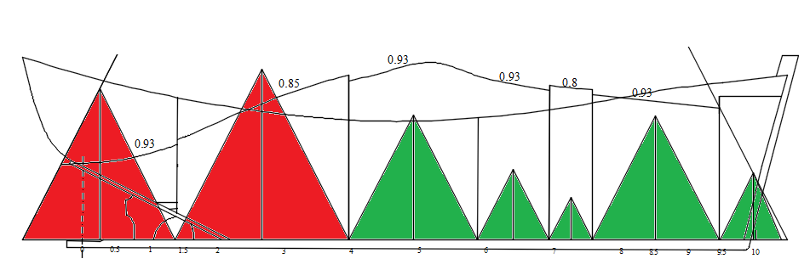
Figure 11. Ship demands 1 compartment standard
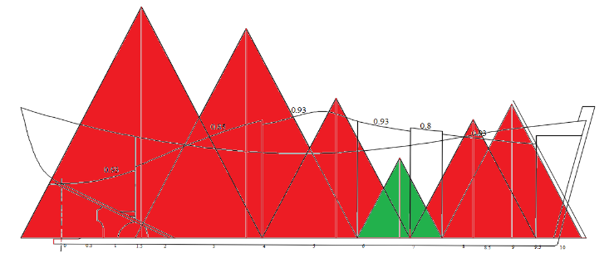
Figure 12. Two compartments standard

Result discussion
- Due to the free surface effect, the case of partially flooded one or more compartments is more dangerous than the case of all fully flooded compartments;
- According to the Figures 11 and 12, the ship will lose the stability if the compartments with the red color are fully flooded.

Conclusions
Based on the results of this research we can see:
- Autoship program can be used to calculate the position, the change of draft, change of trim, heeling and change of stability of the ship easily and fast;
- In this study, the authors use the Added Weight Method in 2 basic cases: with and without free surface effect;
- Deviations between Theory calculating and Autoship program are relatively small;
- The watertight bulkheads of Vietnamese wooden fishing boats are arranged inappropriately. As a result, it could lead to the unsafety of the ship exploitation.

Acknowledgments
This research was supported by The University of Danang, University of Science and Technology. We thank our colleagues from Transportation Mechanical Engineering Faculty, University of Science and Technology, who provided insight and expertise that greatly assisted the research.
We would also like to show our gratitude to the reviewers for their so-called insights.
REFERENCES
- K.J. Rawson, E.C. Tupper.Basic Ship Theory. British Library Cataloguing in Publication Data, 2001.
- Tran Cong Nghi.Ship theory. Ho Chi Minh City University of Transport Publication, 2009.
- Pham Tien Tinh, Le Hong Bang. Ship Design Theory. Vietnam Maritime University Publication, 1995.
- Vietnam Register TCVN6718:2000.
- V.B. Zhinkin. Theory and equipment of ship. Saint-Peterburg, Russia, “Shipbuilding”, 1989.
- L.R. Aksiutin. Control of damaged stability of sea-going vessel. Moscow, Russia, “Transport”, 1974.
- User’s Guidelines for AutoShipSoftware. 2000.

(The Board of Editors received the paper on 10/12/2018, its review was completed on 24/12/2018)

